Requirement Analysis
Customer Journey Map

Date | 30 September 2026
Team ID | SWTID-2026-9545
Project Name | Import Data using Transform Maps (Spreadsheet) – ServiceNow
Maximum Marks

Customer Journey Map:
A customer journey map visualizes the steps the user goes through to reach a goal, together with their actions and experience. Here the “customer” is the ServiceNow administrator importing employee data.
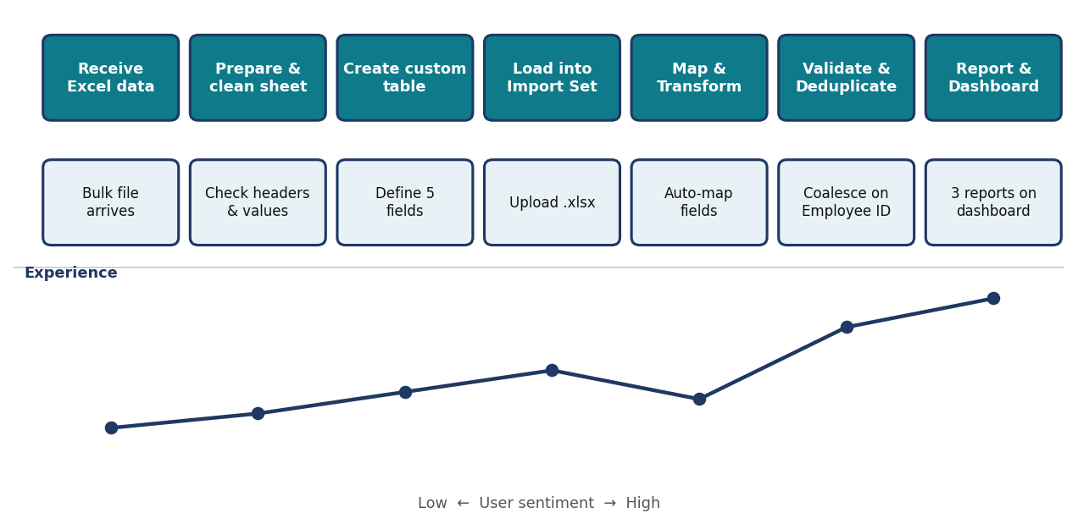
Figure 1: Journey of the administrator from receiving the Excel file to viewing the dashboard
Stage | Touchpoint | User goal | Pain point | Opportunity
Receive Excel data | Email / shared sheet | Get the employee list | Data quality unknown | Review headers and values first
Prepare sheet | Google Sheets | Clean, consistent columns | Inconsistent spellings | Standardize values
Create custom table | Tables > Create New | Target for data | Field setup takes time | Create 5 string fields once
Load into Import Set | Load Data | Stage the file | Wrong sheet or header row | Sheet 1, header row 1
Map & Transform | Transform Map | Map fields correctly | Unmapped fields | Auto Map / Mapping Assist
Validate & Deduplicate | Transform History | No duplicates | Repeat uploads insert again | Coalesce on Employee ID
Report & Dashboard | Reports, Dashboards | Insight into data | No overview | Three reports on one dashboard

